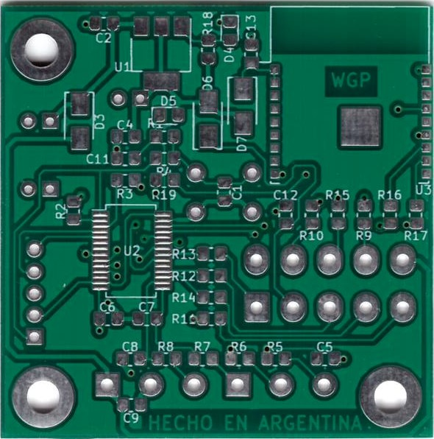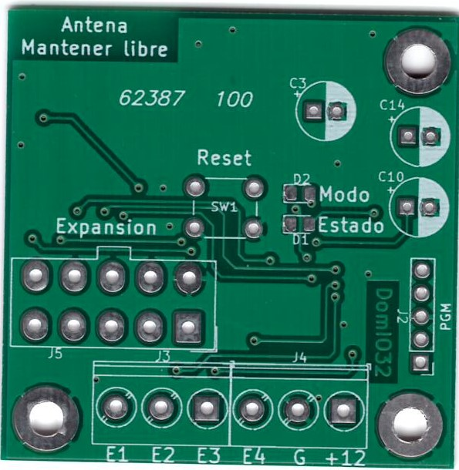
"R1" "10K  "R2" "1K"  "R3" "1K"  "R4" "1K"  "R5" "1K"  "R6" "1K"  "R7" "1K"  "R8" "1K"  "R9" "1K"  "R10" "1K"  "R11" "1K"  "R12" "1K"  "R13" "1K"  "R14" "1K"  "R15" "1K"  "R16" "1K"  "R17" "1K"  "R18" "1K"  "R19" "1K" | "C1" "100nf / 50v"  "C2" "100nf / 50v"  "C3" "100uf / 16v"  "C4" "100nf / 50v"  "C5" "100nf / 50v"  "C6" "100nf / 50v"  "C7" "100nf / 50v"  "C8" "100nf / 50v"  "C9" "100nf / 50v"  "C10" "100uf / 16v"  "C11" "100nf / 50v"  "C12" "100nf / 50v"  "C13" "100nf / 50v"  "C14" "100uf / 16v" | "D1" "Led Rojo"  "D2" "Led Verde"  "D3" "M7"  "D4" "LL4148"  "D5" "LL4148"  "D6" "M7"  "D7" "M7" | "U1" "LM1117-3.3"  "U2" "PIC32MM0064GPL028-I-SS"  "U3" "ESP-02"

